**Number Theory**

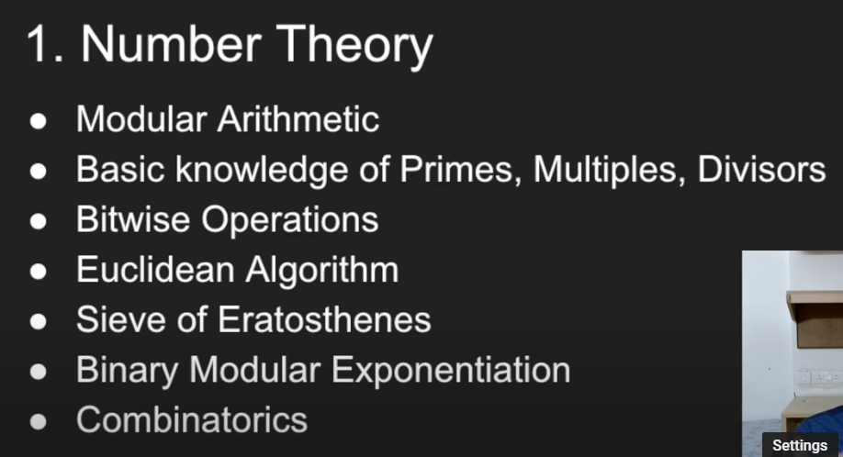

- [CodeNCode Number Theory Playlist](https://www.youtube.com/watch?v=eRkqvQtm4DU&list=PL2q4fbVm1Ik4liHX78IRslXzUr8z5QxsG) - [Number Theory Playlist](https://www.youtube.com/watch?v=dg1CUYrLrD0&list=PL5DyztRVgtRWblnyEHtajWijQffrfwLz6)

- [CP Algorithms Algebra Section](https://cp-algorithms.com/#algebra) -

- [Utkarsh Gupta Quick Number Theory Video](https://www.youtube.com/watch?v=tDM6lT-qjys)

**Binary Search**

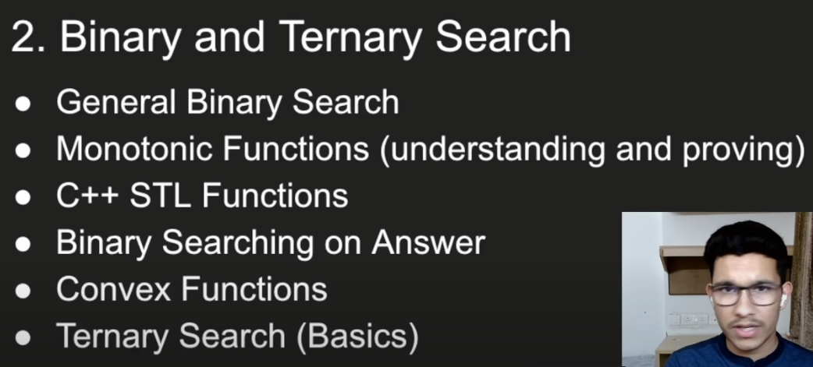

- [Codeforces Edu Section (Binary Search)](https://codeforces.com/edu/course/2/lesson/6/1)

- [Priyansh Agarwal Quick Binary Search Video](https://www.youtube.com/watch?v=TiQ_W2qG3kU)

- [CP Algorithms Ternary Search](https://cp-algorithms.com/num_methods/ternary_search.html)

**Greedy**

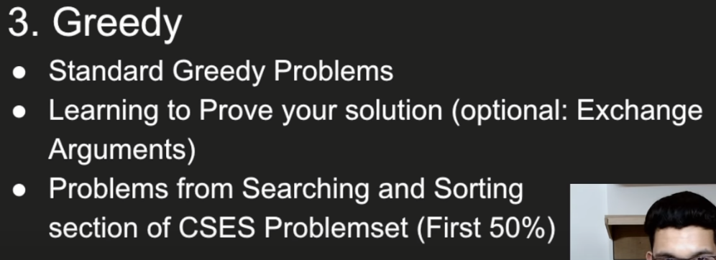

- [Geeks for Geeks Standard Greedy Problems](https://www.geeksforgeeks.org/greedy-algorithms/#standardGreedyAlgorithms)

- [Exchange Arguments Algorithms Live Video](https://www.youtube.com/watch?v=Oq1seKJvfQU)

- [CSES Problemset](https://cses.fi/problemset/) (Try first 50% problems from Searching and Sorting Section)

**Dynamic Programming**

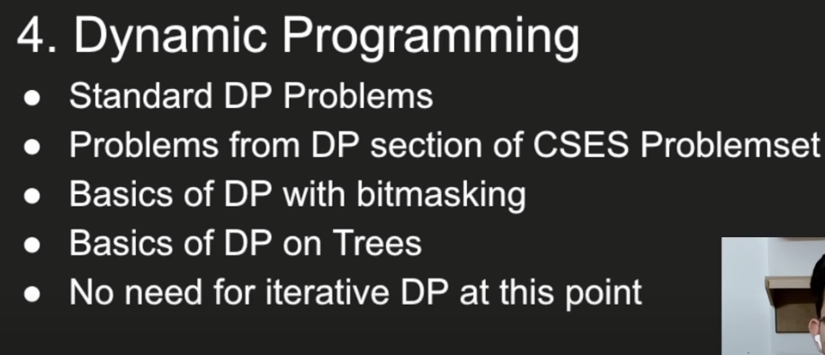

- [Errichto’s DP Beginner Videos](https://www.youtube.com/watch?v=YBSt1jYwVfU&list=PLl0KD3g-oDOGJUdmhFk19LaPgrfmAGQfo)

- [CSES Problemset](https://cses.fi/problemset/) (Try first 60% problems from DP Section)

- [Kartik Arora’s DP Playlist](https://www.youtube.com/watch?v=24hk2qW_BCU&list=PLb3g_Z8nEv1h1w6MI8vNMuL_wrI0FtqE7)

- [AtCoder DP Contest](https://atcoder.jp/contests/dp) (Try first 10 problems)

- [Utkarsh Gupta’s AtCoder Solutions](https://www.youtube.com/watch?v=OlA7gfvN6os&list=PLn8m49B2OVF4nGlNNY_aijlUz8Caiye11) (Hindi)

**Trees**

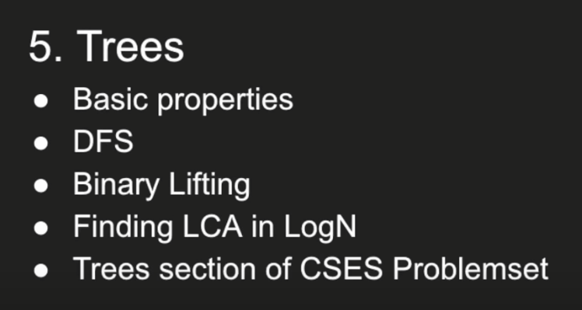

- [Tree Video 1](https://www.youtube.com/watch?v=HL5ouhfxlgk), [Tree Video 2](https://www.youtube.com/watch?v=WXMnRa3NkTQ) on Priyansh Agarwal Channel

- [Galen Collins Trees Topic Stream](https://www.youtube.com/watch?v=mw2J6lvZZJ4)

- [Errichto Binary Lifting Video](https://www.youtube.com/watch?v=oib-XsjFa-M)

- [CSES Problemset](https://cses.fi/problemset/) (Try first 6 problems from Trees Section)

**Graphs**

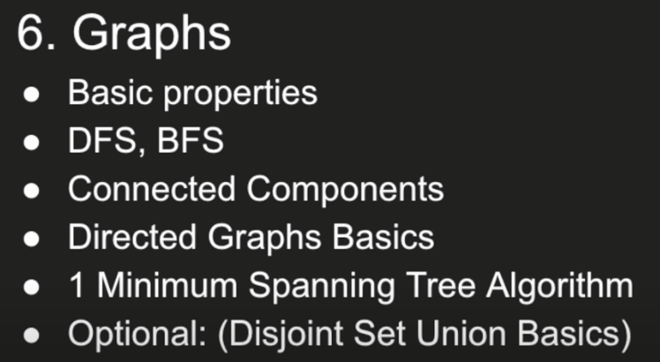

- [Galen Collins Graphs Topic Stream](https://www.youtube.com/watch?v=2hBjTs3qRg0)

- [William Fiset Graph Theory Playlist](https://www.youtube.com/watch?v=DgXR2OWQnLc&list=PLDV1Zeh2NRsDGO4--qE8yH72HFL1Km93P)

- [CSES Problemset](https://cses.fi/problemset/) (Try first 8 problems from Graphs Section)

**Summary of the Video:**

- [Priyansh Agarwal Tweet](https://twitter.com/Priyansh_31Dec/status/1506957085254201344) (This by no means is a replacement of the video)

